HOSPITAL MANAGEMENT SYSTEM
A Web-Based System for Digitizing Patient, Doctor and Appointment Records
Project Documentation Submitted in Partial Fulfilment of the
Requirements for the Diploma in Information Technology (DIT)
Prepared by: Kevin Kibet
Registration No: DIT/05/003346/2025
Department of Information Technology
Supervisor: Geofry Rotich
July 2026

Declaration
I declare that this project documentation is my own original work and has not been submitted to any other institution for academic credit. All sources of information used have been duly acknowledged.
Student Name: Kevin Kibet
Signature: _______________________________ Date: _______________________________
Supervisor Approval
This project documentation has been submitted for examination with my approval as the institution supervisor.
Supervisor Name: Geofry Rotich
Signature: _______________________________ Date: _______________________________

Acknowledgement
I would like to thank the Almighty God for good health throughout the course of this project. My sincere gratitude goes to my supervisor, Geofry Rotich, for the patient guidance and honest feedback given throughout the design and development of this system. I am equally grateful to my lecturers, classmates and family, whose support and encouragement kept me going through every stage of this work.

Abstract
Small and medium-sized hospitals and clinics still depend heavily on paper-based methods for keeping patient records, tracking doctor schedules and managing appointments. This approach is slow, prone to error, and makes it hard to retrieve information quickly when it matters most. This project presents the design and development of a web-based Hospital Management System (HMS) built to address these problems.
The system was built with PHP, MySQL, HTML, CSS and Bootstrap, following a structured design process that began with requirements gathering and system analysis and moved through design using standard modelling tools such as use case diagrams, data flow diagrams, entity relationship diagrams, class diagrams and sequence diagrams. The finished system lets hospital staff register patients, manage doctor profiles, and book and track appointments through a single, centralised web interface.
Testing confirmed that the system meets its stated requirements, including secure login, patient record management and appointment booking with conflict validation. The project shows that a simple, low-cost software solution can meaningfully improve the efficiency of hospital administration, and it provides a base that can later be extended with billing, pharmacy and laboratory modules.
Keywords: Hospital Management System, PHP, MySQL, Patient Records, Appointment Scheduling, Web-Based System

Table of Contents
Declaration ii
Acknowledgement iii
Abstract iv
List of Figures vii
Chapter One: Introduction 1
1.1 Background of the Study 1
1.2 Statement of the Problem 1
1.3 Objectives of the Study 1
1.4 Scope of the Project 2
1.5 Significance of the Study 2
1.6 Limitations of the Study 2
1.7 Definition of Terms 3
1.8 Organisation of the Report 3
Chapter Two: Literature Review 4
2.1 Overview of Hospital Record Management 4
2.2 Challenges of Manual Systems 4
2.3 Review of Existing Digital Solutions 4
2.4 Manual System versus the Proposed System 5
2.5 Research Gap 5
Chapter Three: Methodology and System Design 6
3.1 System Development Methodology 6
3.2 Requirements Gathering Techniques 6
3.3 Feasibility Study 6
3.4 Analysis of the Existing and Proposed Systems 6
3.5 System Requirements 7
3.6 System Design 7
3.7 Database Design 16
Chapter Four: System Implementation and Testing 17
4.1 Development Environment and Tools 17
4.2 Key Modules Implemented 17
4.3 Sample Implementation 17
4.4 Testing Approach 18
4.5 Test Results and Discussion 18
Chapter Five: Summary, Conclusion and Recommendations 20
5.1 Summary and Challenges Encountered 20
5.2 Conclusion 20
5.3 Recommendations for Future Work 21
References 22
Appendix: Sample User Guide 23

List of Figures
Figure 3.1: Use Case Diagram of the Hospital Management System
Figure 3.2: Class Diagram
Figure 3.3: Sequence Diagram – Login Process
Figure 3.4: Activity Diagram – Appointment Booking
Figure 3.5: Data Flow Diagram – Context Level
Figure 3.6: Data Flow Diagram – Level 1
Figure 3.7: Entity Relationship Diagram
Figure 3.8: System Architecture Diagram
Figure 3.9: Deployment Diagram

Chapter One: Introduction

1.1 Background of the Study
Hospitals and clinics, particularly the smaller ones, sit at the centre of community healthcare delivery. How well they manage patient records, doctor schedules and appointments has a direct bearing on the quality of service they can offer. Many small hospitals still rely on paper registers and physical filing cabinets to store patient information. As the number of patients grows, this manual approach becomes harder to sustain, leading to delays, lost records and scheduling conflicts.
The Hospital Management System (HMS) described in this documentation was built in response to these challenges. It is a web-based application that brings patient registration, doctor management and appointment booking into one searchable digital system, accessible through an ordinary web browser.

1.2 Statement of the Problem
Patient records scattered across paper files are difficult to retrieve quickly, especially during emergencies. Appointment scheduling done by hand often leads to double-booked doctors and long patient waiting times. Doctors have no centralised way to check a patient's history during a consultation, which can affect the quality of diagnosis. Producing routine administrative reports, such as the number of patients seen in a week, is slow and error-prone without a digital system, and paper records remain vulnerable to physical damage, loss and unauthorised access.

1.3 Objectives of the Study
The main objective of this project was to design and develop a web-based Hospital Management System that digitises patient registration, appointment booking and doctor management for a small hospital or clinic. This was pursued through the following specific objectives:
- To analyse the existing manual record-keeping process and identify its shortcomings.
- To design a system architecture and database structure suitable for managing patients, doctors and appointments.
- To develop a web-based application implementing patient registration, doctor management and appointment booking modules.
- To test the developed system against defined functional and non-functional requirements.
- To document the system's design and development process for future reference and extension.

1.4 Scope of the Project
The system covers patient registration, doctor management and appointment booking, together with a simple admin dashboard that summarises key statistics. Billing, pharmacy and laboratory modules were left out of this version of the system; they are discussed as recommendations for future work in Chapter Five.

1.5 Significance of the Study
A working HMS reduces the time staff spend searching for patient records, which improves response time during consultations, and it minimises scheduling conflicts through centralised appointment tracking. It also improves the overall quality and professionalism of service delivery, gives hospital administrators quick access to summarised statistics for decision-making, and provides a foundation that can later be extended with billing, pharmacy and laboratory modules. Beyond its immediate use, the project also serves as a learning resource for other students undertaking similar systems.

1.6 Limitations of the Study
The system was developed and tested in a simulated environment rather than a live hospital, owing to time and access constraints. It does not currently handle billing, insurance claims or pharmacy inventory, and issues such as internet connectivity and power outages, which are common in some deployment settings, were not addressed within the scope of this project.

1.7 Definition of Terms
- HMS – Hospital Management System, the software developed in this project.
- ERD – Entity Relationship Diagram, a diagram showing database entities and their relationships.
- DFD – Data Flow Diagram, a diagram showing how data moves through a system.
- CRUD – Create, Read, Update, Delete, the basic operations performed on stored data.
- Front-end – the part of the system the user interacts with directly.
- Back-end – the server-side logic and database that process and store data.

1.8 Organisation of the Report
The rest of this report is organised into four further chapters. Chapter Two reviews relevant literature on hospital record management and existing digital solutions. Chapter Three describes the methodology followed and presents the system's analysis and design, including the key UML diagrams and the database design. Chapter Four covers system implementation and testing, and Chapter Five closes with a summary of challenges encountered, the project's conclusions and recommendations for future work.

Chapter Two: Literature Review

2.1 Overview of Hospital Record Management
Hospital record management is the process of capturing, storing and retrieving information about patients, staff and hospital operations. Historically this has been done by hand, using paper files, index cards and physical registers. Manual systems are simple to set up and need no technical training, but they run into serious limitations as the volume of records grows.
As a hospital or clinic grows, the number of registers in use tends to grow with it, and different departments often end up keeping their own separate records of the same patient. Over time this makes it difficult to build a single, reliable view of a patient's history, and it slows down the everyday work of clinicians and administrative staff alike.

2.2 Challenges of Manual Systems
Retrieving a specific patient record quickly becomes difficult once archives grow large or old, and paper is always at risk from fire, water damage, misplacement or ordinary wear. Without a unique identifier for each patient, duplicate records are common, and compiling statistics or reports by hand is slow. Perhaps most seriously, manual registers rarely have any real backup mechanism, so a single incident can wipe out years of records.
These weaknesses are not merely inconvenient; they have a direct effect on patient care. A doctor who cannot quickly confirm a patient's history may repeat tests unnecessarily or miss information relevant to a diagnosis, and a receptionist working from a paper diary has no reliable way to confirm, at a glance, whether a particular doctor is already booked at a given time.

2.3 Review of Existing Digital Solutions
A number of digital hospital and health management information systems already exist, ranging from large enterprise platforms used in referral hospitals to open-source systems such as OpenMRS and Bahmni, which are widely used across developing regions. These systems typically bundle registration, billing, pharmacy, laboratory and reporting into one large package.
While powerful, such systems are often complex to install, configure and maintain, and they tend to demand hardware and technical expertise that small clinics simply do not have. Configuring modules that a small clinic will never use adds unnecessary overhead, and the cost of hosting or licensing such systems can be difficult to justify for a facility with only a handful of staff. This leaves room for a lighter, easier-to-deploy system built around the core needs of smaller facilities: patient registration, doctor management and appointment booking.

2.4 Manual System versus the Proposed System
Where the manual system relies on paper files and registers, the proposed HMS keeps everything in a centralised digital database. Record retrieval moves from slow manual searching to fast, searchable lookups, and the near-inevitable duplication of paper records is minimised through unique patient IDs. Appointment scheduling, which is manual and conflict-prone on paper, becomes a digital process with built-in validation, while reporting shifts from manually compiled figures to a dashboard of summarised statistics. Data security improves from relying on physical access control alone to requiring a login, and database backups become possible where they were rarely done before.

2.5 Research Gap
Taken together, the literature points to a clear need for lightweight hospital management solutions built for small clinics that cannot adopt large enterprise systems. This project addresses that gap by focusing on the essential modules — patient registration, doctor management and appointment booking — while keeping the system simple enough to install and operate with minimal technical support.

Chapter Three: Methodology and System Design

3.1 System Development Methodology
This project followed the Waterfall Model of the Software Development Life Cycle, chosen because the system's requirements were well-defined and relatively stable from the outset. The model was applied through its usual sequential phases: requirements gathering and analysis, system design, implementation, testing, deployment and maintenance.

3.2 Requirements Gathering Techniques
Requirements were gathered through informal interviews with clinic staff to understand day-to-day recordkeeping challenges, direct observation of the paper-based registers and forms already in use, and a review of literature and existing digital hospital systems to identify good practice worth carrying into this project.

3.3 Feasibility Study
On the technical side, the system proved feasible because it relies on widely available, free and well-documented technologies — PHP, MySQL, HTML, CSS and JavaScript — all of which run on the free XAMPP stack without any specialised hardware. Economically, the project required no licensing costs, since every tool used, including XAMPP and Visual Studio Code, is free and open-source; the only real cost was development time and a standard computer. Operationally, the system was designed around a simple, intuitive interface aimed at non-technical hospital staff such as receptionists, so that it can be picked up with minimal training.

3.4 Analysis of the Existing and Proposed Systems
The existing manual system depends on paper registers for recording patient details and appointments: new patients fill in a registration card that is then filed physically, and appointments are noted in a diary or appointment book by the receptionist. This process is slow and error-prone, and it makes it hard to cross-check a doctor's availability before confirming a new booking.
The proposed system replaces this manual process with a centralised web application. Receptionists register patients directly into the system, doctors' schedules are stored digitally, and appointments are checked against existing bookings before they are confirmed. All information lives in a relational database, which allows for quick retrieval and reporting.

3.5 System Requirements
Functionally, the system allows an admin or receptionist to log in securely with a username and password; supports registering, viewing, editing and deleting patient records; allows registration and management of doctor profiles, including specialisation and schedule; and allows appointments to be booked between a patient and a doctor, with validation to prevent double-booking. It also supports updating an appointment's status between Pending, Confirmed and Completed, displays a dashboard summarising total patients, doctors and appointments, and restricts access to authorised users only.
On the non-functional side, the interface needed to be simple enough for non-technical staff to use with minimal training, and pages needed to load within about two seconds under normal use on a local network. Only authenticated users may access patient data, and passwords are stored in hashed form. The system handles invalid input gracefully rather than crashing, its code is organised into clear modules to simplify future updates, and the database is designed so that further modules, such as billing, can be added later without major restructuring.

3.6 System Design
This section presents the models used to design the system: behavioural views through the use case and sequence diagrams, structural views through the class diagram and entity relationship diagram, and physical views through the data flow, architecture and deployment diagrams.

3.6.1 Use Case Diagram
The use case diagram below shows the system's main actors — Admin, Receptionist, Doctor and Patient — and how each of them interacts with the system's core functions.
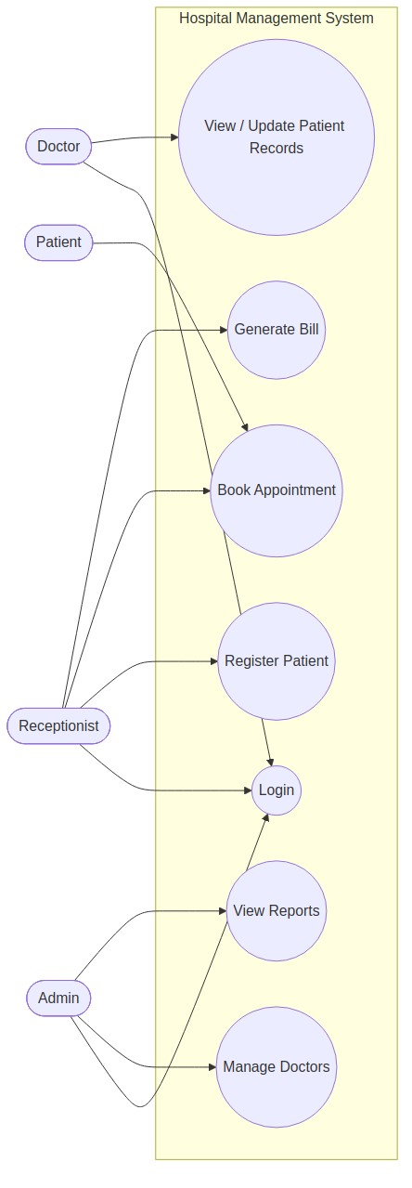
Figure 3.1: Use Case Diagram of the Hospital Management System

3.6.2 Class Diagram
The class diagram models the key object classes in the system, along with their attributes, operations and the relationships between them.
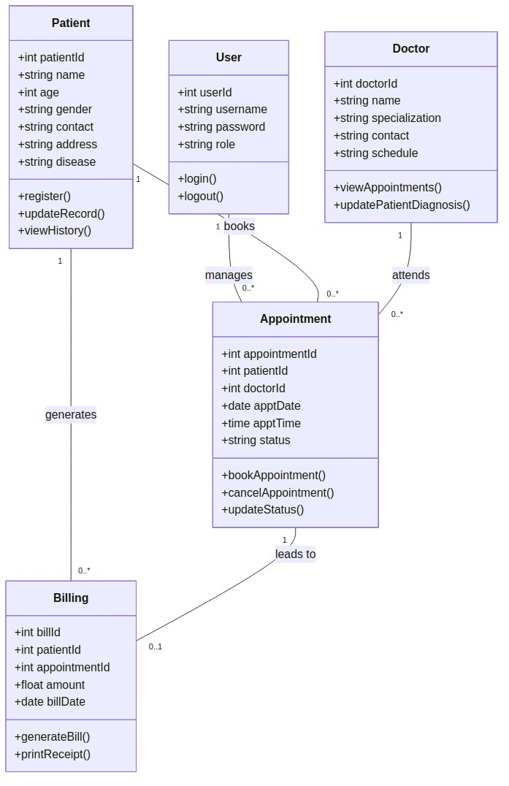
Figure 3.2: Class Diagram

3.6.3 Sequence Diagram – Login Process
The sequence diagram below illustrates the interaction between the receptionist, the login interface, the application server and the database during the login process, from the initial submission of credentials to the final redirect to the dashboard.
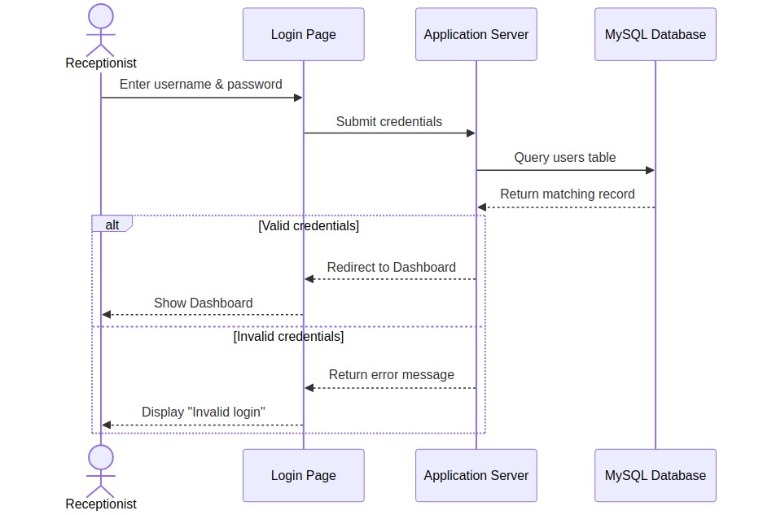
Figure 3.3: Sequence Diagram – Login Process

3.6.4 Activity Diagram – Appointment Booking
The activity diagram below models the step-by-step logic followed when booking an appointment, including the validation check that prevents a doctor from being double-booked.
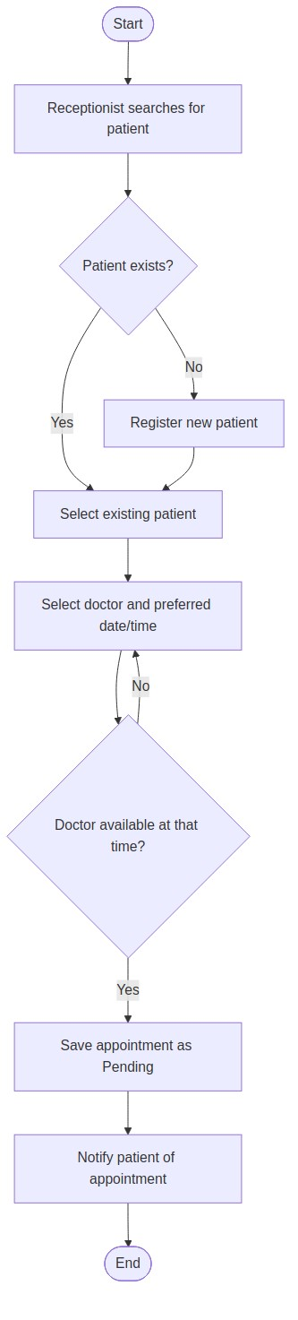
Figure 3.4: Activity Diagram – Appointment Booking

3.6.5 Data Flow Diagrams
The context diagram below treats the system as a single process and shows how it exchanges data with its external entities — the Patient, Doctor and Admin/Receptionist.
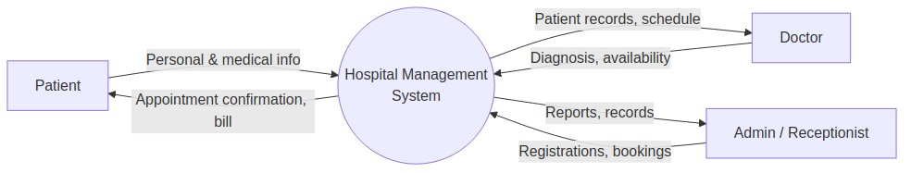
Figure 3.5: Data Flow Diagram – Context Level
The Level 1 diagram that follows breaks the system down into its four core processes — registering patients, managing doctors, booking appointments and generating reports — and shows how data moves between these processes and the underlying data stores.
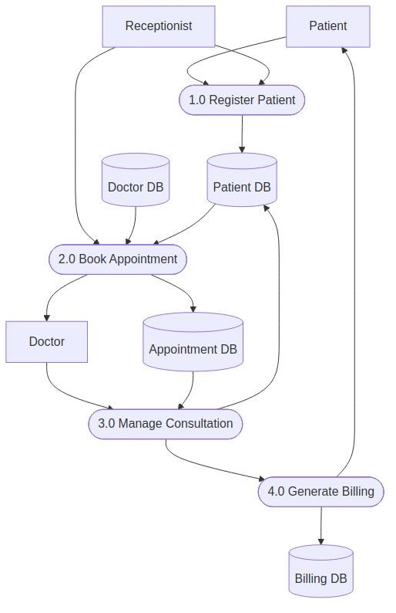
Figure 3.6: Data Flow Diagram – Level 1

3.6.6 Entity Relationship Diagram
The entity relationship diagram below models the database structure — patients, doctors, appointments, billing and system users — together with their relationships and key attributes.
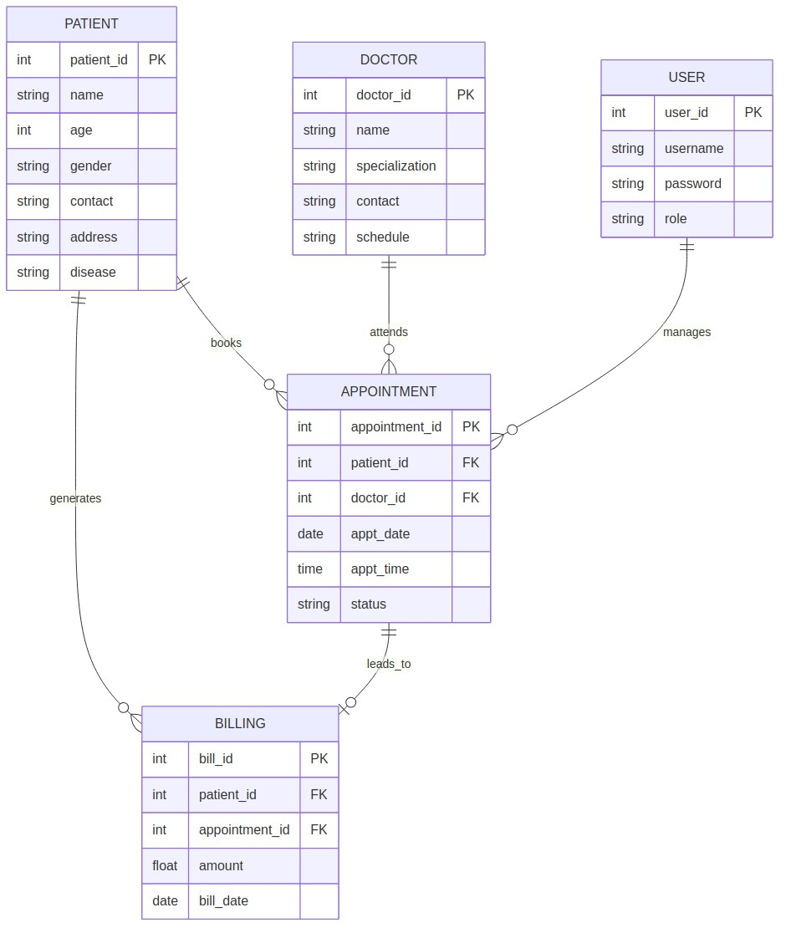
Figure 3.7: Entity Relationship Diagram

3.6.7 System Architecture
The system follows a simple three-layer, client-server architecture made up of a presentation layer (the browser-based interface), an application layer (PHP business logic) and a data layer (the MySQL database).
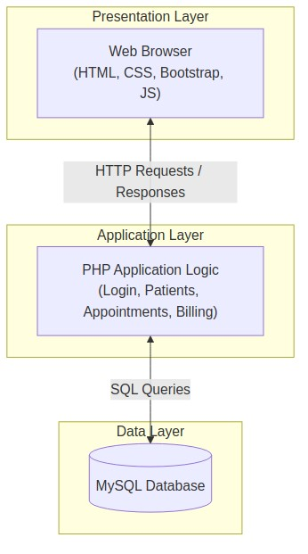
Figure 3.8: System Architecture Diagram

3.6.8 Deployment Diagram
The deployment diagram shows how the system's components are physically distributed between the client machine, which runs only a web browser, and the server machine, which runs the XAMPP stack (Apache, PHP and MySQL).
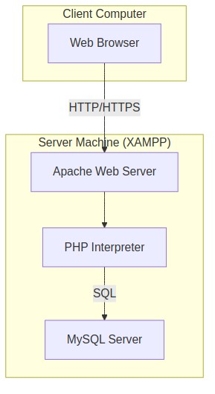
Figure 3.9: Deployment Diagram

3.6.9 Interface Design Overview
The interface was kept clean and minimal, built with Bootstrap components for consistency. The login page uses simple username and password fields; the dashboard shows summary cards for total patients, doctors and appointments; the patient page lists patients in a searchable view with add, edit and delete actions; the doctor page lists doctors with their specialisation and schedule; and the appointment page provides a form for selecting a patient, doctor, date and time, alongside a list of upcoming appointments.

3.7 Database Design
The database is organised into five related tables, linked through foreign keys as shown in the entity relationship diagram in Section 3.6.3. The patients table stores a unique patient ID together with each patient's name, age, gender, contact number, address and presenting condition. The doctors table stores a doctor ID, name, specialisation, contact number and working schedule.
The appointments table ties patients to doctors through foreign keys on patient ID and doctor ID, and records the appointment date, time and status (Pending, Confirmed or Completed). A billing table was included at design stage to record charges linked to a given appointment, even though the billing module itself was left for future work, and a users table stores login credentials — username, a hashed password, and a role of Admin, Receptionist or Doctor — for every system user.
The design was normalised to the Third Normal Form to reduce redundancy and protect data integrity: each table represents a single entity, every non-key attribute depends fully on the primary key, and related tables are linked through foreign keys rather than by repeating data. Appointments, for instance, reference a patient ID and doctor ID instead of duplicating patient and doctor details.

Chapter Four: System Implementation and Testing

4.1 Development Environment and Tools
The interface was built with HTML, CSS, Bootstrap and JavaScript, while PHP handled the server-side logic and MySQL provided the database, all served locally through Apache via XAMPP. Draw.io and Mermaid were used to produce the UML and system diagrams presented in Chapter Three, and Visual Studio Code served as the primary code editor throughout development.
Development followed the phases of the Waterfall model described in Chapter Three, with each module implemented and tested individually before being integrated into the full system. This made it easier to isolate and fix problems, since a fault in the appointment module, for example, could be diagnosed without needing to consider the patient or doctor modules at the same time.

4.2 Key Modules Implemented
The finished system is organised into five modules. The login module authenticates users before granting access to the rest of the system. The patient module handles registration, editing and viewing of patient records, while the doctor module manages doctor profiles and specialisations. The appointment module allows appointments to be booked and tracked, and the dashboard module displays summarised statistics for the admin.

4.3 Sample Implementation
The excerpt below, taken from the patient registration script, shows how a new patient's details are captured from a submitted form and inserted into the database using a prepared statement, which protects against SQL injection.
if ($_SERVER['REQUEST_METHOD'] == 'POST') {
$name = $_POST['name'];
$age = $_POST['age'];
$gender = $_POST['gender'];
$contact = $_POST['contact'];
$stmt = $conn->prepare(
'INSERT INTO patients (name, age, gender, contact) VALUES (?, ?, ?, ?)'
);
$stmt->bind_param('siss', $name, $age, $gender, $contact);
$stmt->execute();
header('Location: patients.php');
}
A similar pattern, shown next, is used when booking an appointment: the system first checks for a scheduling conflict before saving the new record, querying existing appointments for the chosen doctor, date and time, and only proceeding to insert the new appointment if no match is found.
$check = $conn->prepare(
'SELECT * FROM appointments WHERE doctor_id = ? AND appt_date = ? AND appt_time = ?'
);
$check->bind_param('iss', $doctor_id, $date, $time);
$check->execute();
$result = $check->get_result();
if ($result->num_rows > 0) {
echo 'Doctor already booked at this time.';
} else {
// proceed to insert the new appointment
}

4.4 Testing Approach
The system was tested through a combination of unit testing of individual functions such as login and date validation, integration testing to confirm that modules such as appointments and patients work correctly together, system testing of the complete workflow from login to appointment confirmation, and user acceptance testing in which a non-technical user, playing the role of a receptionist, attempted the system's common tasks.

4.5 Test Results and Discussion
Login was tested with both correct and incorrect credentials: valid credentials correctly redirected to the dashboard, and invalid ones produced a clear error message rather than granting access. Patient registration was tested with complete and incomplete data — valid details were saved and listed correctly, while an empty name field triggered a validation error instead of an empty record.
Appointment booking was tested under normal conditions, with missing fields, and with a deliberately conflicting time slot. In each case the system behaved as expected: a valid booking was saved with a Pending status, an empty date field produced a validation error, and attempting to book a doctor who was already scheduled at that time produced a conflict warning rather than a second, overlapping appointment. Editing and deleting patient records, and viewing dashboard statistics, were also confirmed to work correctly.
Taken together, these results confirm that the system meets its stated functional requirements for patient registration, doctor management and appointment booking, including basic input validation and conflict detection. No critical defects were found during testing; the issues that did come up, such as an early version of the date picker accepting past dates, were minor and were corrected before the final round of testing. The consistent pass results across unit, integration, system and acceptance testing give reasonable confidence that the system is ready for use in a simulated or small-scale real-world setting.

Chapter Five: Summary, Conclusion and Recommendations

5.1 Summary and Challenges Encountered
Building this system was not without its difficulties. Keeping data consistent across the patients, doctors and appointments tables required care during development, and designing an interface simple enough for non-technical hospital staff without sacrificing functionality took several iterations. Validating date and time input to prevent doctors being double-booked needed particular attention, and balancing the overall scope of the project against the time available meant that billing and pharmacy modules had to be deferred to future work. Learning to model the system properly with UML diagrams before writing any code was also, in itself, a valuable part of the process.

5.2 Conclusion
The Hospital Management System developed in this project successfully digitises the core operations of patient registration, doctor management and appointment booking. It shows how a relatively simple web application, built entirely from freely available tools, can meaningfully improve efficiency in a small hospital or clinic compared with manual, paper-based record keeping.
Beyond the working system itself, the project demonstrates a complete software development process — from requirements gathering and feasibility analysis, through system design using industry-standard diagrams, to implementation and testing — and leaves a solid foundation on which future enhancements can be built.
More broadly, the project reinforces the idea that meaningful improvements to hospital administration do not always require large, expensive systems. A well-scoped application, built around the specific needs of a small facility and grounded in a disciplined design process, can deliver real gains in speed, accuracy and reliability over paper-based methods, while remaining simple enough for the staff who will actually use it every day.

5.3 Recommendations for Future Work
- Add a billing and payment module with receipt generation.
- Integrate SMS or email reminders for upcoming appointments.
- Add a pharmacy and inventory management module with stock and expiry tracking.
- Add a laboratory module for managing test requests and results.
- Introduce separate, role-based dashboards for doctors and admins, each tailored to their needs.
- Add data analytics and visual charts for tracking hospital performance over time.
- Deploy the system on a cloud server to allow remote access from multiple hospital branches.

References
PHP Documentation. Available at: https://www.php.net/docs.php
MySQL Documentation. Available at: https://dev.mysql.com/doc/
Bootstrap Documentation. Available at: https://getbootstrap.com/docs/
OpenMRS – Open Source Electronic Medical Record System. Available at: https://openmrs.org/
Bahmni – Open Source Hospital System. Available at: https://www.bahmni.org/
Sommerville, I. Software Engineering (10th Edition). Pearson Education.

Appendix: Sample User Guide

A.1 Logging In
Open the system in a web browser at the assigned local address (for example, localhost/hms), enter the assigned username and password, and click 'Login' to reach the dashboard.

A.2 Registering a New Patient
From the dashboard, click 'Patients', then 'Add New Patient'. Fill in the patient's name, age, gender, contact and address, then click 'Save' to add the patient to the system.

A.3 Booking an Appointment
From the dashboard, click 'Appointments', then 'Book New Appointment'. Select the patient and doctor from the dropdown lists, choose a date and time, and click 'Book'. The system will confirm the booking, or show a warning if the doctor is already booked at that time.

A.4 Managing Doctor Profiles
From the dashboard, click 'Doctors' to view the list of registered doctors. Click 'Add New Doctor' to capture a doctor's name, specialisation, contact details and schedule, or select an existing doctor to edit or remove their profile.

